Talula Pontuti

Jan 21, 2022

Week 1 Exercise 1

Map 1: Dot Density Map

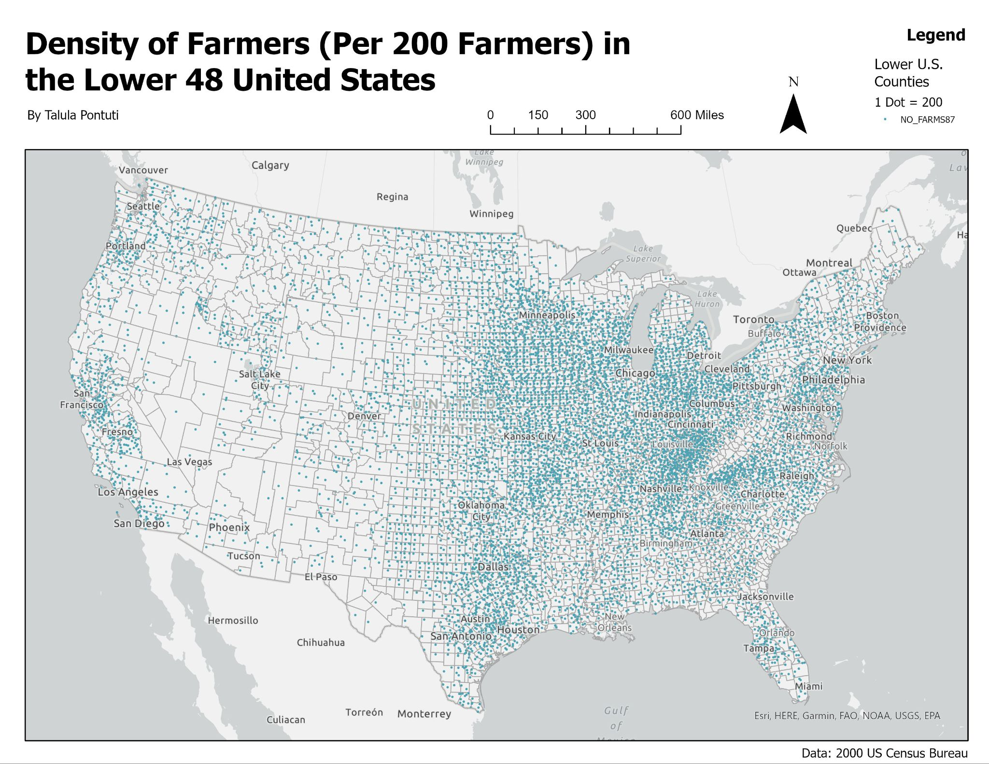

In this first map, we see clusters of farmers in the central California area, in the midwest, and in the central east of the contingent U.S. This likely explained by historically popular agriculture areas and unique growing conditions for various popular crops/range areas. This may also be due to locations of large agricultural companies over the years that have been selected for various reasons. I chose to keep the colors simple to not overwhelm the viewer, along with choosing a dot size that was easy to see but could still illustrate clustering. I wanted to clean up the legend a bit to make the information clearer, but had a hard time editing some of the information so I look forward to improving my skills in that.

Map 2:

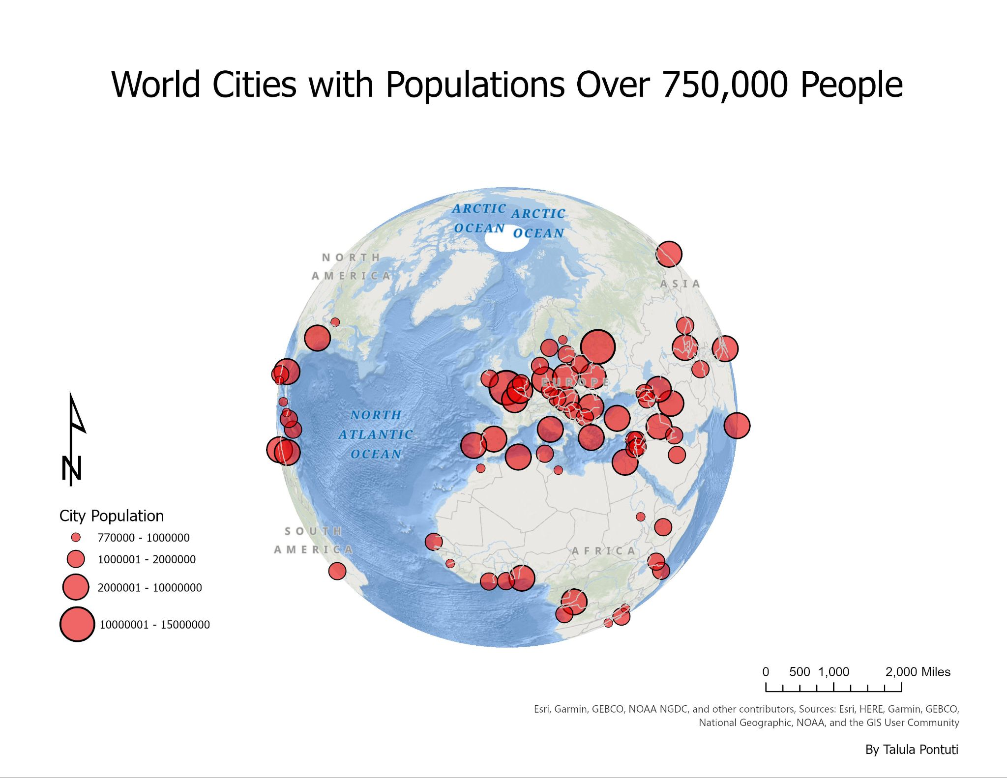

This map shows large population clusters for part of the world - centered in on Europe. Many of these areas have historically had high population clusters for various reasons, including livable climates. This map was interesting to make, especially when trying to find clear ways to represent the population cluster sizing.

Map 3:

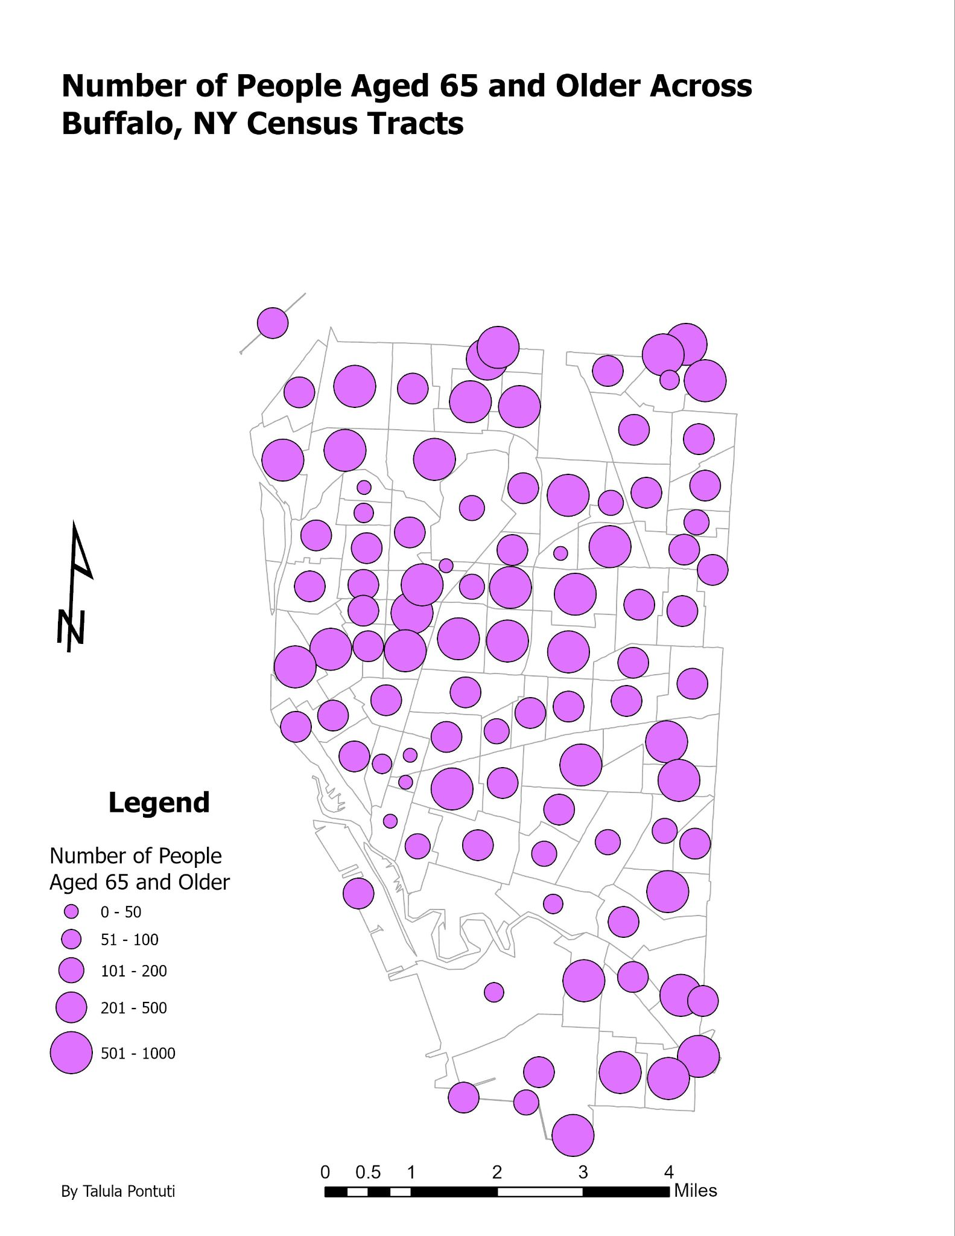

This map shows the older population concentrations across Buffalo, NY. We can see the clustering here of higher populations along the boundaries of Buffalo and some centrally. When thinking about relationships - I have to remember that I know nothing about Buffalo as an area, but I would assume that outside of the city center is more favorable housing for older folks, or it may have to do with affordability and other resources available. I don’t quite like how I set up this map and will look at better design throughout this class.

Map 4:

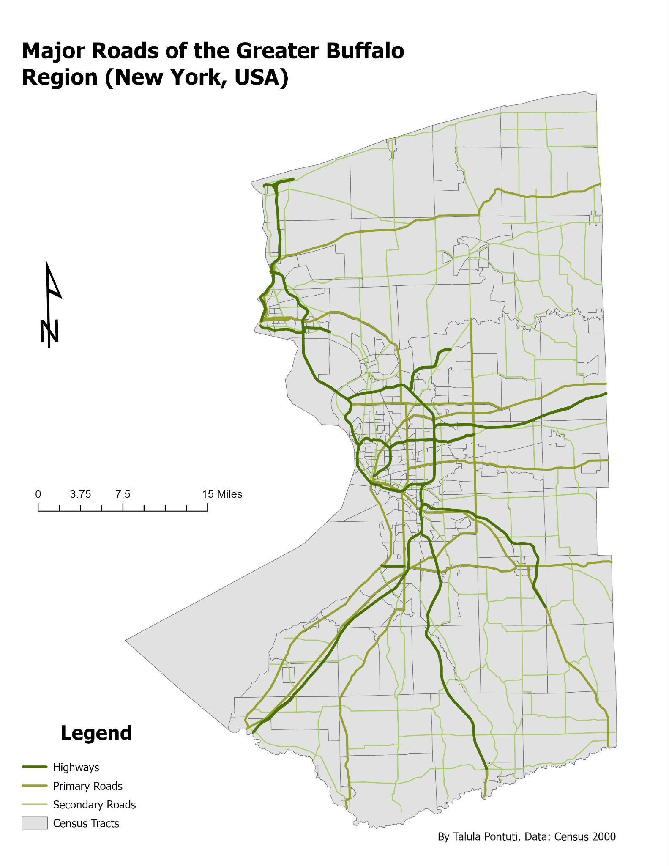

This map was interesting to make. I chose the green colors and grey because they were relatively easy to take in visually, but maybe they are a bit too similar or large.

Map 5:

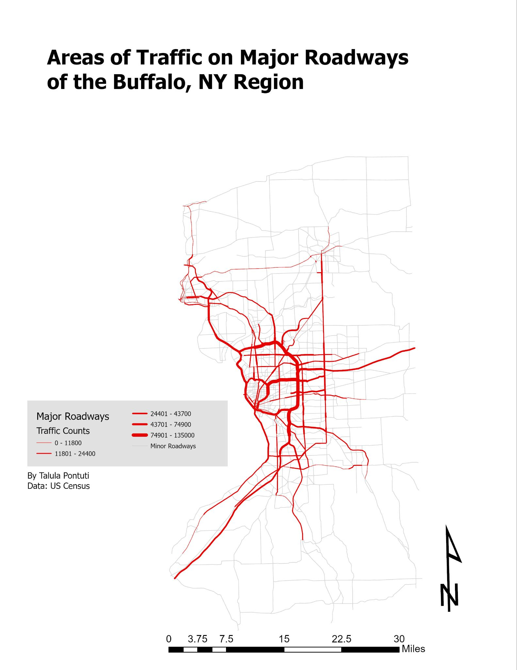

The traffic patterns here make sense with the major roadways we saw in Map 4. My layout is a little odd with all of the white so next time I may include a border of the Buffalo area.